B. Voc- Hospitality & Tourism (L-4)
On the Job Training (OJT) – 1st Semester
Job Role- Front Office Associate

After the completion of first semester, B. Voc Hospitality & Tourism(H&T) , students undergoes one month local OJT at 4 Hotels in Shimla. The OJT took place from 1st December 2022 to 1st Janurary 2023. Total 22 students enrolled in OJT. Details are given below:-
- Hotel Radisson Jass- 9 Students
OJT done under supervision of Miss. Reetika HR manager.
- Hotel Combermere- 4 students
OJT done under supervision of Mr. Ishwar Chauhan HR manager.
- Hotel Oberio Clarkes- 8 students
OJT done under supervision of Mr. Rahul HR manager.
- Hotel Snow land- 1 Students
OJT done under supervision of Mr. Girish Janartha HR manager.

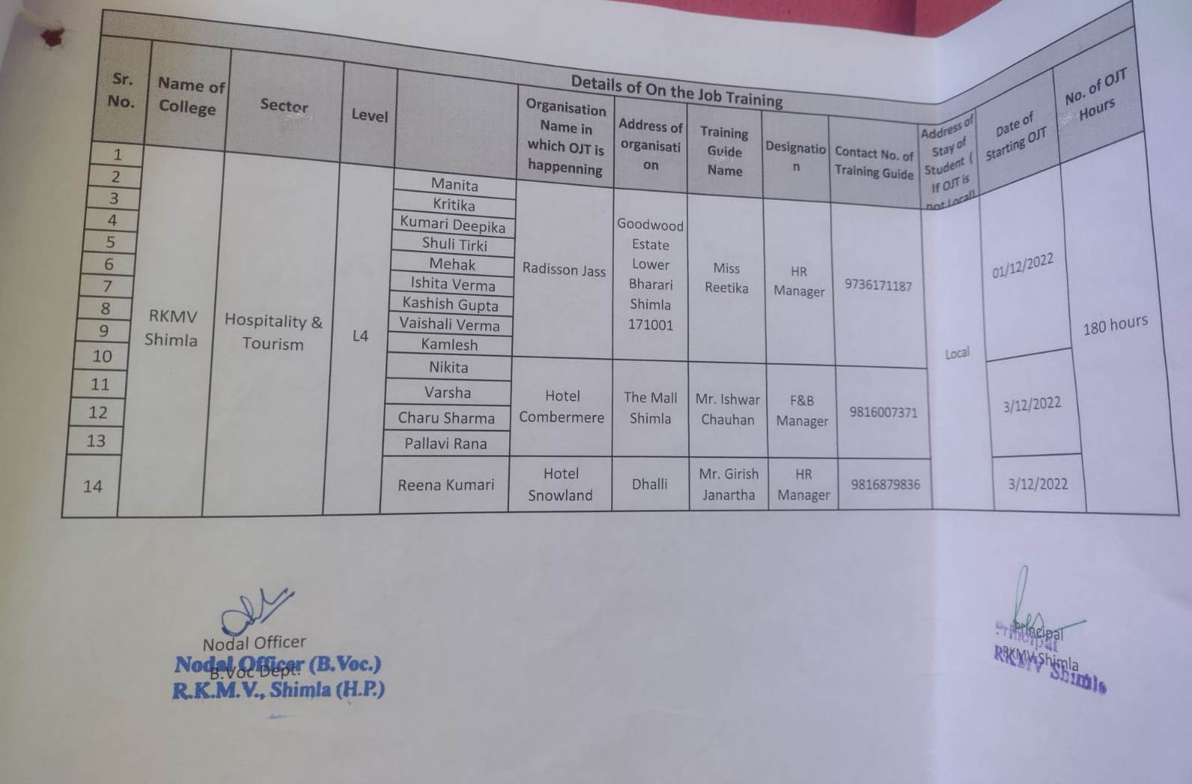

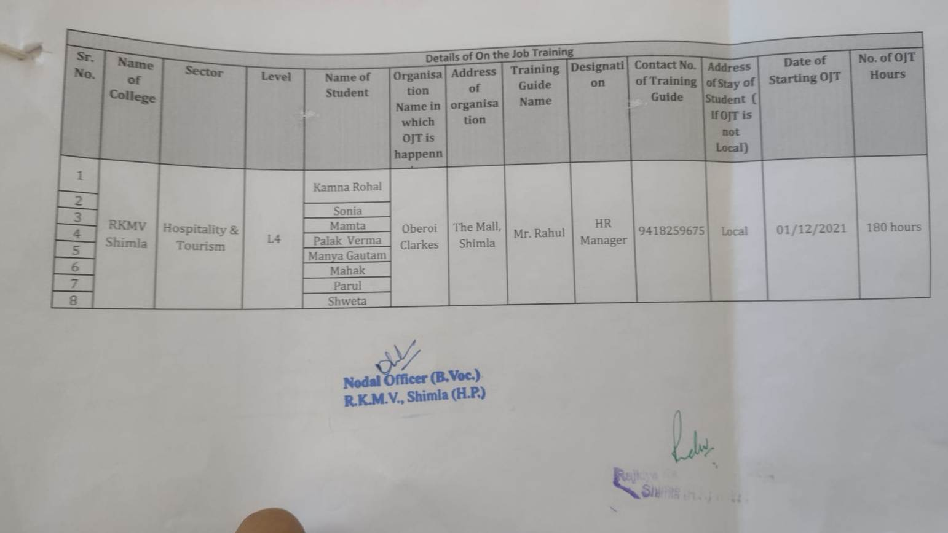

OJT Approval Level -4
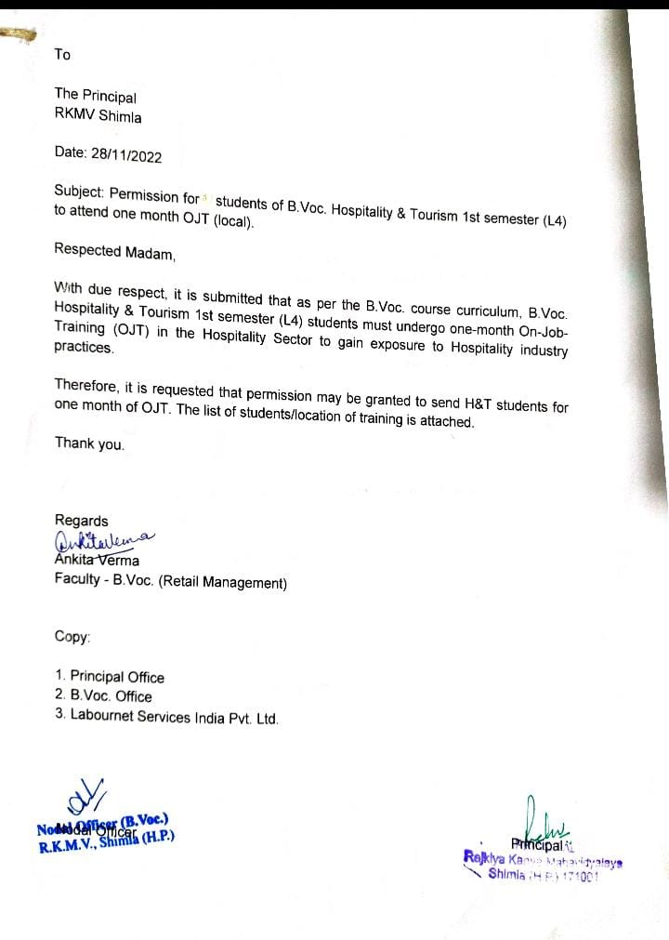

OBJECTIVE OF OJT

The Objective of this OJT was to enhance students Industrial exposure so that students can acquire first hand experience of a Hospitality Industry.
It will increase the practical knowledge of the students which they will perform during their OJT period
By the end of the OJT Students learnt these all things:-
- Knowledge of different departments of the Hotel Indusrty.
- Greeting guest as per the time.
- Knowledge of different softwares used in hospitality Industry.
- Students also learned the grooming standards which is followed in Hotels.
- Handling Guest Complaints
- Maintaining par Stock in every department.
- Reporting discrepancies and problems to their supervisor
- Learned Check in & Check out process by following all SOP’S
- Learned how to handle reservation queries.
- Learned how to take orders & how to resolve queries.

PHOTOS OF STUDENTS DURING ON THE JOB TRAINING IN HOTELS

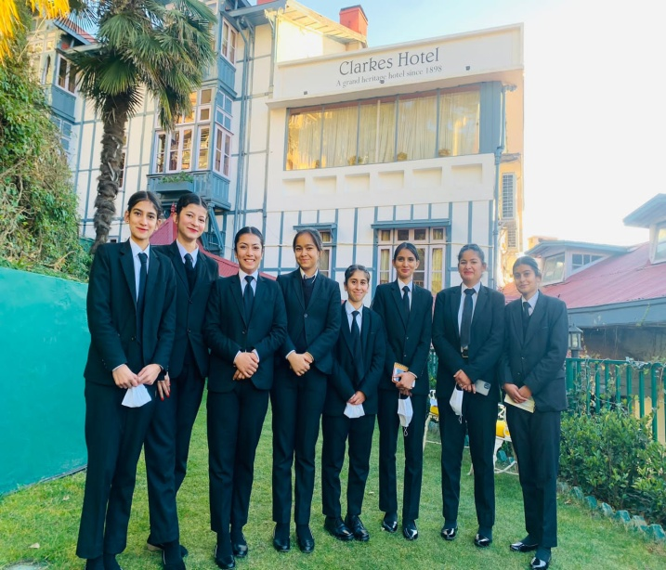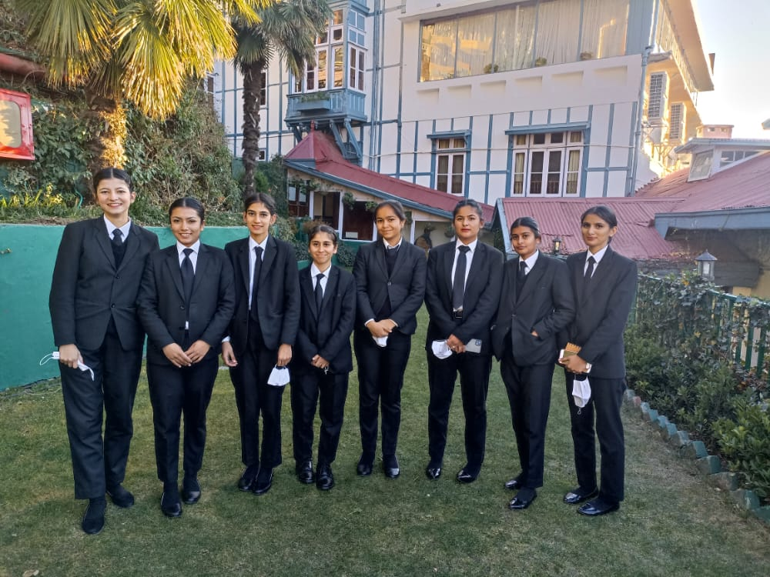

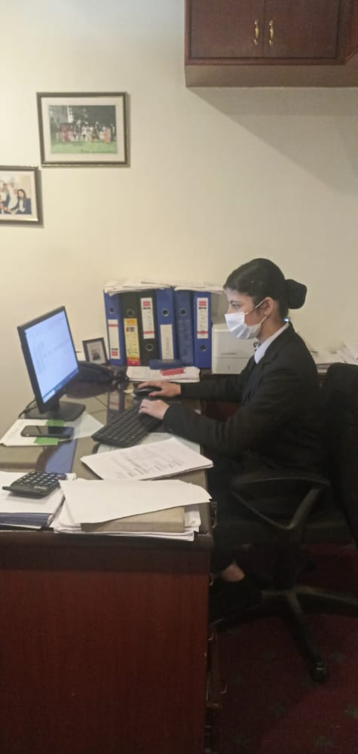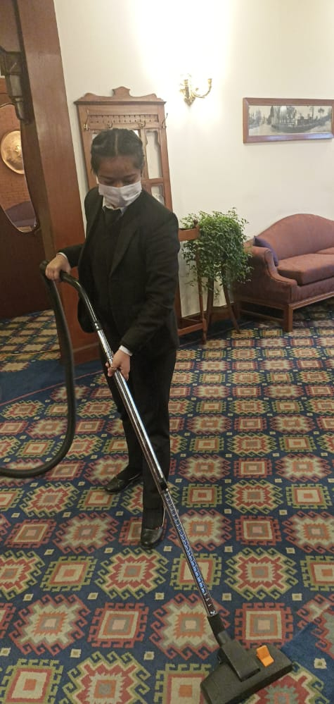
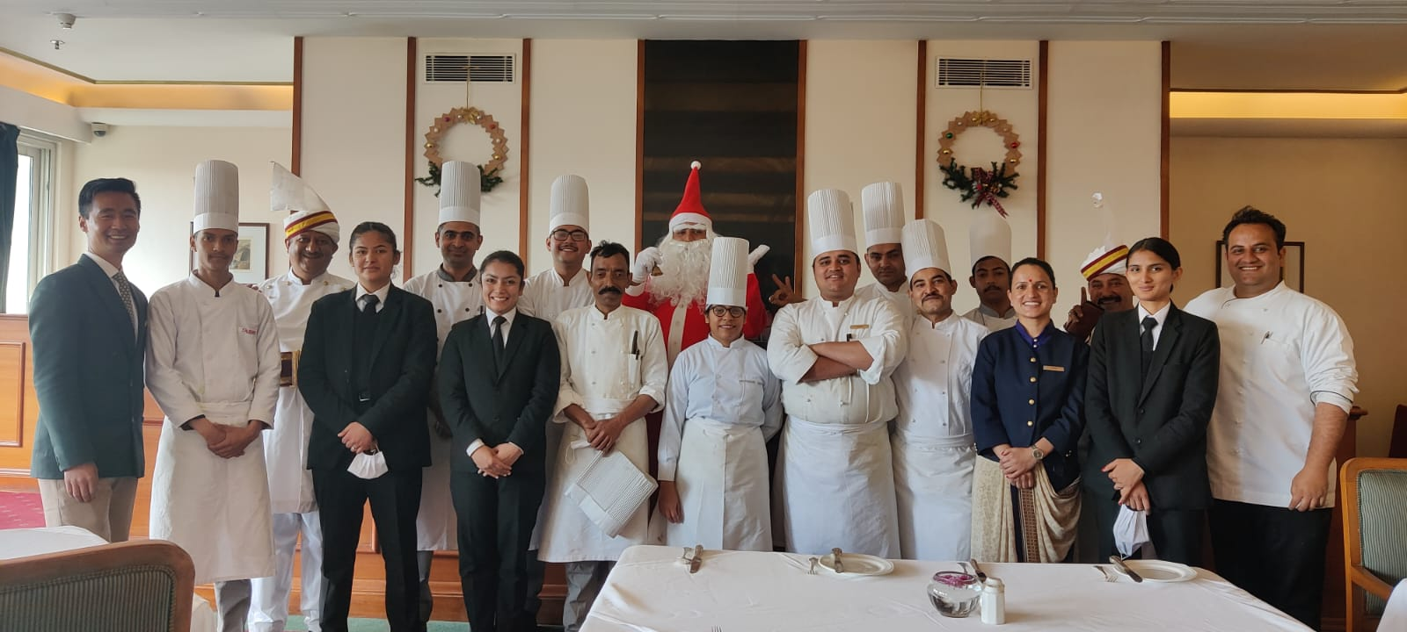
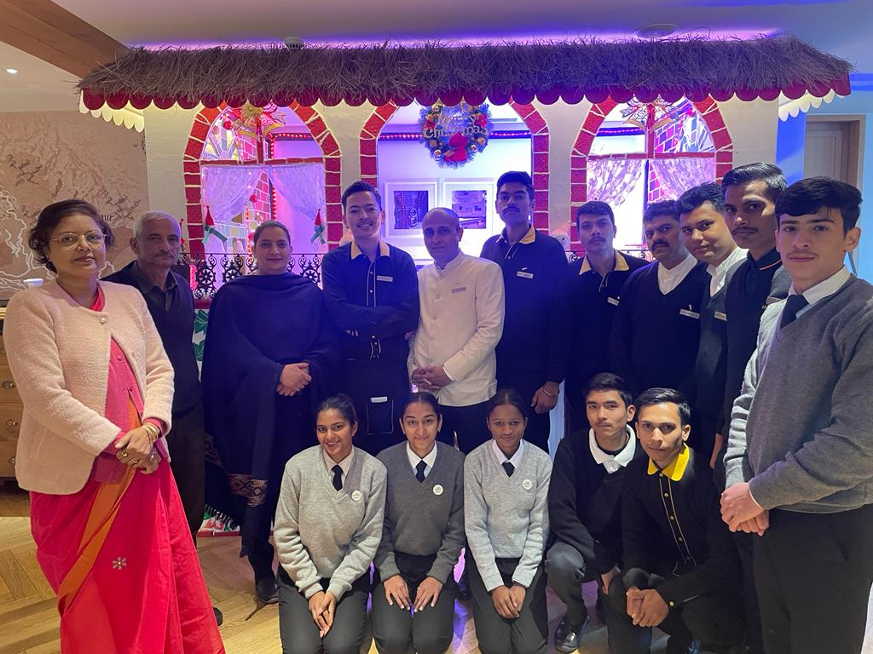
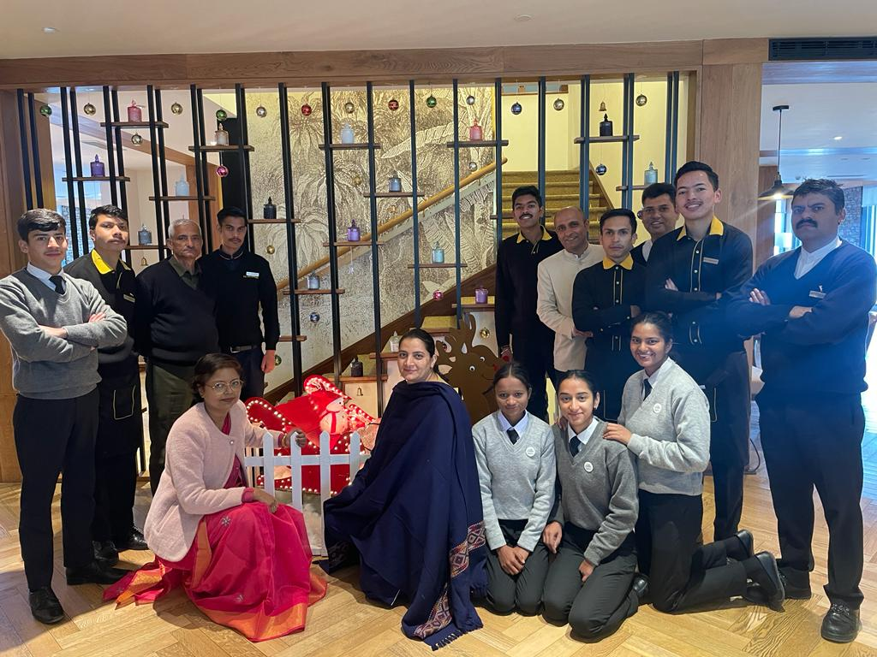
CERTIICATES OF STUDENTS
